**The Equivalence Route**

**to**

**The Register of**

**Clinical Technologists**

Table of Contents

Introduction 3

Evidence Portfolio 4

Evidence Matrix 5

Application Process 6

Step 1 6

Step 2 6

Step 3: 6

Step 4 6

Step 5 6

Step 6: 6

Assessment 7

Assessment Flowchart 8

Appeals 9

# Introduction

A Voluntary Register of Clinical Technologists was first proposed in 2000 with a view to making a platform which would lead to the Statutory Registration of Clinical Technologists.

The structure of the register was then worked on over a number of years to meet the requirements of the Department of Health (DoH) and the then Health Professions Council, now Health and Care Professions Council (HCPC).

In 2005 the Health Professions Council agreed that Clinical Technologists, along with a number of other healthcare professions, should be regulated and come under their auspices. Officers of the RCT worked with the DoH and HCPC to fine tune the application for statutory registration but, because of conflicting demands on government time, the necessary legislation was still not enacted and in 2010 the government changed policy and decided not to create further statutory registers unless there was *‘a compelling case on the basis of a public safety risk and where assured voluntary registers are not considered sufficient to manage this risk’*

Since 2010, when the grand parenting route closed, the only routes onto the Register have been via approved training schemes. With the introduction of the Practitioner Training Programme (PTP) degrees under the Modernising Scientific Careers (MSC) initiative, another route to the register has been added: successfully completing a PTP approved degree will enable a candidate to join the register.

There are, however, a large number of clinical technologists who already may have equivalent training and experience and for whom the training programmes are not appropriate. These may include:

* Technologists with overseas qualifications.
* Technologists with a large relevant experience from other professions.
* Technologists who missed out on grandparenting.
* Technologists who have followed a training programme other than those approved by the RCT member bodies.

The equivalence route is designed to enable these technologists to achieve registration by demonstrating that their levels of knowledge and skills are at least equivalent to those offered by the relevant Scope of Practice and the RCT Equivalence Standards - Engineering or RCT Equivalence Standards – Physics. These documents can be found on the RCT website.

# Evidence Portfolio

The candidate will be expected to produce a report and a supporting portfolio of evidence to accompany their applications form, to enable RCT Assessors to make a judgment that equivalence is demonstrated. The report should include:

1. A detailed summary of the candidate’s previous training and experience. This should include details of a period of directly relevant training for the current post.
2. Details of recent and ongoing activities which give evidence of knowledge and skills matching the Scope of Practice. The document ‘RCT Equivalence Standards – Engineering and RCT Equivalence Standards - Physics” lists the categories that evidence should match to demonstrate equivalence.
3. Any evidence which you are submitting should be copies of your own work but must contain no patient identifiable data. Please ensure that anything that is submitted is completely anonymised and failure to do so will result in your portfolio being returned.
4. Although it is not a requirement that the candidate should already hold a first degree, the evidence should reflect that the candidate is working at a level which requires that level of education.
5. Evidence that the candidate is familiar with the principles of ‘Good Scientific Practice’
6. Evidence that the candidate has good use of English and is able to communicate well with patients and other healthcare professionals.
7. Evidence that the candidate has a command of numeracy commensurate with degree level learning.
8. Copies of relevant training certificates.

# Evidence Matrix

It is expected that matrices will be included showing whereabouts in the report/portfolio each ‘evidence criterion’ and ‘scope of practice’ is covered. The entirety of the report should demonstrate that the candidate is capable of a piece of work that is **accepted degree standard**. Where there are areas which the candidate does not cover in their normal day to day work, there should be a written submission demonstrating their knowledge of that area.

Application forms and examples of what is expected are available from the RCT website.

Once the report/portfolio is completed, it will be reviewed by an assessors’ panel. An interview may be conducted if necessary to enable the panel to be satisfied with the candidate’s equivalence status. The outcome of this assessment will be given in writing. Successful candidates’ names will be added to the RCT.

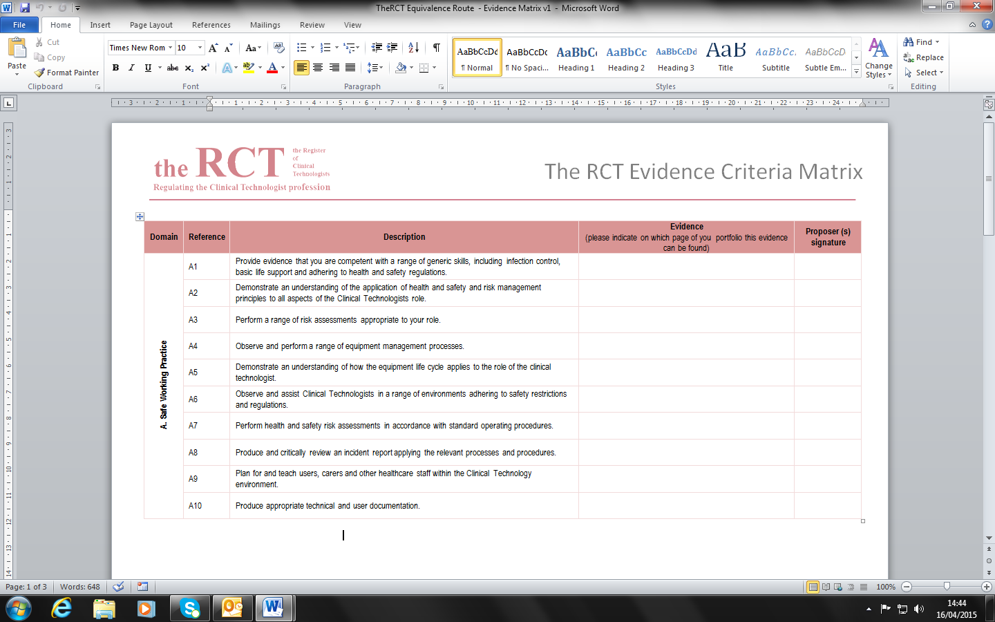

# Application Process

|  |  |
| --- | --- |
| Step 1: | Applicants should familiarise themselves with the following:-   * [**Scope of Practice for the area in which they work**](http://therct.org.uk/scope-of-practice/) * [[**RCT Equivalence Standards - Engineering**](http://therct.org.uk/how-to-join-the-register/equivalence-for-engineering/)](http://therct.org.uk/scope-of-practice/) * [**RCT Equivalence Standards - Physics**](http://therct.org.uk/how-to-join-the-register/equivalence-for-physics/) * **The RCT Evidence Matrix relevant to your scope of practice (**[**Engineering**](http://therct.org.uk/wp-content/uploads/2019/06/TheRCT-Equivalence-Route-Evidence-Matrix-Engineering.docx)**,** [**Nuclear Medicine**](http://therct.org.uk/wp-content/uploads/2016/01/The-RCT-Equivalence-Route-Evidence-Matrix-Nuclear-Medicine.docx)**,** [**Radiation Physics**](http://therct.org.uk/wp-content/uploads/2016/05/The-RCT-Equivalence-Route-Evidence-Matrix-Radiation-Physics.docx) **or** [**Radiotherapy Physics**](http://therct.org.uk/wp-content/uploads/2016/05/The-RCT-Equivalence-Route-Evidence-Matrix-Radiotherapy-Physics.docx)**)** * [**Application Guidance Notes**](http://therct.org.uk/wp-content/uploads/2019/04/RCT-Guidance-Notes-for-Applicants-and-Information-for-Registrants.pdf) |
| Step 2: | Applicants must prepare a portfolio to provide evidence that they can meet the equivalence requirements. |
| Step 3: | Applicants should download and complete the application form and return to the RCT **in electronic format only (Either via USB, email or Dropbox)** with the required supporting documentation.  The application must contain the following:   * + Certificates of academic attainment (initialled by both Proposers)   + Curriculum Vitae   + Current Job Description (initialled on each page by both Proposers)   + Organisational structure chart (initialled by both Proposers)   + The RCT Evidence Matrix (signed against each standard by one Proposer)   + Portfolio   + Direct debit form |
| Step 4: | Two assessors will be appointed to evaluate a submission. |
| Step 5: | If the assessors are satisfied that equivalence has been demonstrated, you will be advised in writing and formally added to the register. |
| Step 6: | If the assessors are not satisfied with the submission, they may:   1. Return it with comments on where there are weaknesses to be addressed or 2. Advise that equivalence has not been demonstrated and a formal training programme should be undertaken   Invite the applicant for professional review |

**Assessment**

The RCT Equivalence Standards - Engineering / Physics and Scope of Practice explain the level that you are expected to have reached, demonstrated through your portfolio of evidence.

Proposers are asked to sign off your evidence matrix to confirm that they can verify your achievement to the standards.

Applications will be assessed separately by two carefully selected assessors. Each assessor will decide, via the evidence submitted, if the standard has been sufficiently evidenced. Where this can be clearly demonstrated the assessor will return a “yes”. Where there is a lack of evidence the assessor will return a “no”. Where there is a discord of marks which cannot be agreed, you will be eligible to re-submit your evidence and may, at the discretion of the assessors be invited to attend a professional review.

The total number of “yes’s” from both assessors will be added together and where this is equal to 100% it will be deemed that the applicant has achieved the minimum standard of equivalence to be entered on to the Register. Where the standard is not met applicants will be able to:-

|  |  |
| --- | --- |
| Standards achieved | Applicant |
| 100% | Admitted to the Register |
| 99% - 90% | Applicant invited to re-submit within 3 months  If, on the second submission , the evidence is not sufficient to achieve 100% the applicant may be invited to attend a professional review, at the discretion of the assessment panel, or rejected and invited to re-submit in 6 months |
| 89% or less | Applicant rejected and not eligible to re-resubmit for at least 6 months. |

# 

# Assessment Flowchart



# Appeals

Appeals can only be made on the process used by the RCT, not on the outcome of the assessment and interview. If you wish to appeal against the process that has led to a particular decision in relation to your application, you should in the first instance write to:-

The Registrar

The Register of Clinical Technologists

Fairmount House

230 Tadcaster Road

York

YO24 1ES

Email: [enquiries@theRCT.org.uk](mailto:enquiries@theRCT.org.uk)

Your letter/email will be acknowledged and two members of the RCT will be appointed to review your application and submit a report on their findings. You will be informed of the decision.